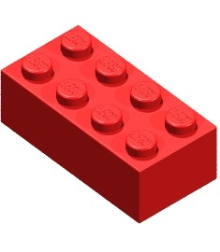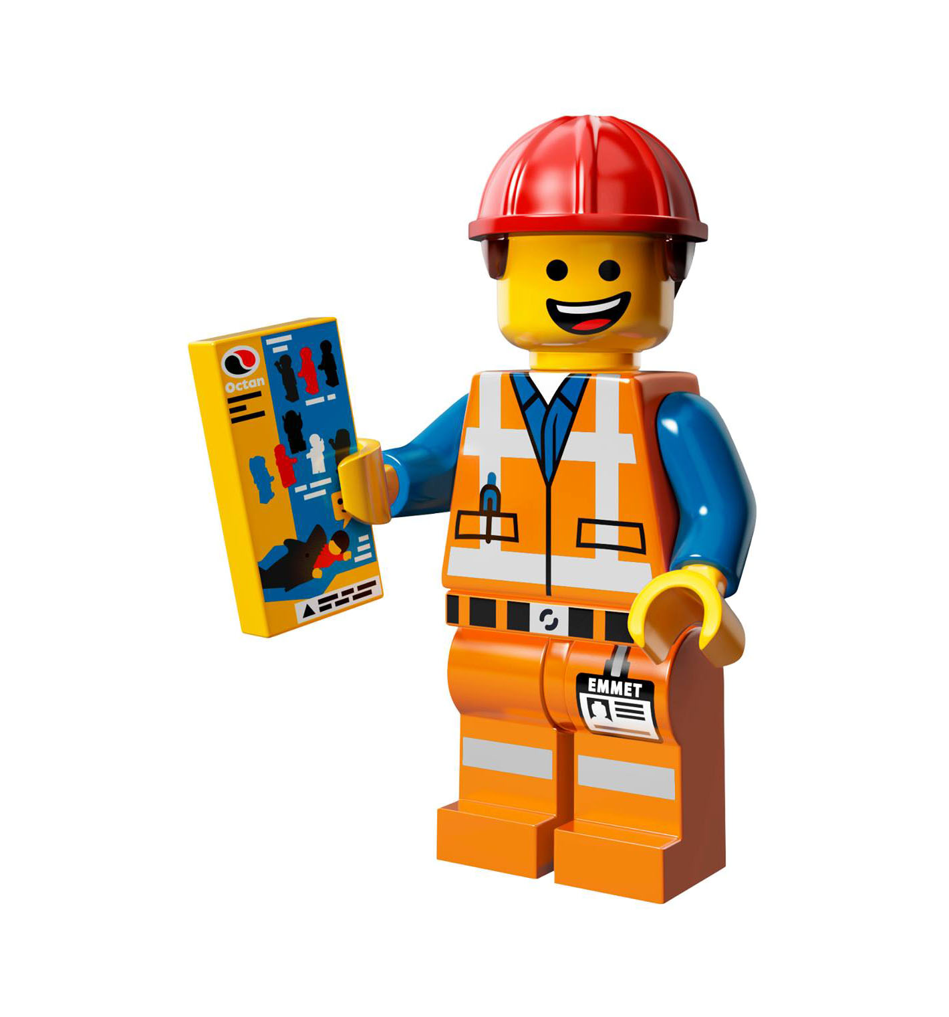

**Abbotsbury LEGO Exhibition**

**Saturday June 2nd, 2018**

at Abbotsbury Uniting Church

Cnr Stockdale and Cowpasture

Roads, Abbotsbury

www.abbotsbury.unitingchurch.org.au

This year we are hosting a massive LEGO exhibition, and a competition open to Students in Preschool - Year 6. Older children and adults are invited to contribute to the exhibition - no entry fee (and alas, no prizes), but a good excuse to get the LEGO out again. The exhibition on Saturday is open to all. Cost of entry is $4 per person or $10 per family.

**How to Enter:**

* Bring your model, entry form and entry fee ($4 per entry) to the church on Friday 1st June from 5:00pm - 7:00pm.
* Exhibition is open on Saturday 2nd June from 9am - 2pm
* Collect your model from the church on Saturday 2nd September from 2 - 3pm.

**Categories:**

* Original Model - Model must have been designed and built by the entrant
* Set Presentation - Model must be built by the entrant but the design is not original (e.g. Uses model instructions / internet instructions/ photos)

**Rules:**

* Lego compatible bricks like Duplo, Megablocks and Kreo may be used as well as / instead of Lego
* The Judges’ decision is final.

**Abbotsbury LEGO Exhibition**

**Saturday June 2nd, 2018**

at Abbotsbury Uniting Church

Cnr Stockdale and Cowpasture

Roads, Abbotsbury

www.abbotsbury.unitingchurch.org.au

This year we are hosting a massive LEGO exhibition, and a competition open to Students in Preschool - Year 6. Older children and adults are invited to contribute to the exhibition - no entry fee (and alas, no prizes), but a good excuse to get the LEGO out again. The exhibition on Saturday is open to all. Cost of entry is $4 per person or $10 per family.

**How to Enter:**

* Bring your model, entry form and entry fee ($4 per entry) to the church on Friday 1st June from 5:00pm - 7:00pm.
* Exhibition is open on Saturday 2nd June from 9am - 2pm
* Collect your model from the church on Saturday 2nd September from 2 - 3pm.

**Categories:**

* Original Model - Model must have been designed and built by the entrant
* Set Presentation - Model must be built by the entrant but the design is not original (e.g. Uses model instructions / internet instructions/ photos)

**Rules:**

* Lego compatible bricks like Duplo, Megablocks and Kreo may be used as well as / instead of Lego
* The Judges’ decision is final.

**Abbotsbury LEGO Exhibition**

**Saturday June 2nd, 2018**

at Abbotsbury Uniting Church

Cnr Stockdale and Cowpasture

Roads, Abbotsbury

www.abbotsbury.unitingchurch.org.au

This year we are hosting a massive LEGO exhibition, and a competition open to Students in Preschool - Year 6. Older children and adults are invited to contribute to the exhibition - no entry fee (and alas, no prizes), but a good excuse to get the LEGO out again. The exhibition on Saturday is open to all. Cost of entry is $4 per person or $10 per family.

**How to Enter:**

* Bring your model, entry form and entry fee ($4 per entry) to the church on Friday 1st June from 5:00pm - 7:00pm.
* Exhibition is open on Saturday 2nd June from 9am - 2pm
* Collect your model from the church on Saturday 2nd September from 2 - 3pm.

**Categories:**

* Original Model - Model must have been designed and built by the entrant
* Set Presentation - Model must be built by the entrant but the design is not original (e.g. Uses model instructions / internet instructions/ photos)

**Rules:**

* Lego compatible bricks like Duplo, Megablocks and Kreo may be used as well as / instead of Lego
* The Judges’ decision is final.

Lego Exhibition Entry Form

Name: _____________________________

Phone: _____________________________

Email: _____________________________

**Competition (please highlight) - $4 per entry**

* Preschool Original Model
* Preschool Set Presentation
* Kindy - Year 2 Original Model
* Kindy - Year 2 Set Presentation
* Year 3 - Year 6 Original Model
* Year 3 - Year 6 Set Presentation

The number and value of prizes is dependent on number of entries in the category: the more entries, the more prizes

**Display - no entry fee**



Name:

______________________

Title of Model ________________________

Category (e.g Yr 3-6 Set Presentation) ________________________



Lego Exhibition Entry Form

Name: _____________________________

Phone: _____________________________

Email: _____________________________

**Competition (please highlight) - $4 per entry**

* Preschool Original Model
* Preschool Set Presentation
* Kindy - Year 2 Original Model
* Kindy - Year 2 Set Presentation
* Year 3 - Year 6 Original Model
* Year 3 - Year 6 Set Presentation

The number and value of prizes is dependent on number of entries in the category: the more entries, the more prizes

**Display - no entry fee**



Name:

______________________

Title of Model ________________________

Category (e.g Yr 3-6 Set Presentation) ________________________



Lego Exhibition Entry Form

Name: _____________________________

Phone: _____________________________

Email: _____________________________

**Competition (please highlight) - $4 per entry**

* Preschool Original Model
* Preschool Set Presentation
* Kindy - Year 2 Original Model
* Kindy - Year 2 Set Presentation
* Year 3 - Year 6 Original Model
* Year 3 - Year 6 Set Presentation

The number and value of prizes is dependent on number of entries in the category: the more entries, the more prizes

**Display - no entry fee**



Name:

______________________

Title of Model ________________________

Category (e.g Yr 3-6 Set Presentation) ________________________

